

INSTRUCTION FOR USE (IFU)

Low-Intensity VHF-UHF
Therapy Apparatus
BIOL

 | Manufacturer:  LLC «LABORATORY OF SYSTEMIC BLOOD RESEARCH «BIOPROMIN» (Biopromin LLC) 02660, Kyiv, Vyzvolyteliv str., 3, office 301  Telephone: +380973423922  email: bioluch@gmail.com | 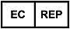 | Authorized representative in European Union:  ONKOCET Ltd.  47 Pribisova str., 84105 Bratislava, Slovakia, Tel.: +421 (2) 44 64 09 77  e-mail: onkocet@onkocet.eu  URL: www.onkocet.eu

The Instructions for use, including all its sections, is protected by the copyright. Any use of materials from this manual that violates the requirements of the current copyright law without the written permission of the manufacturer is prohibited.
This provision concerns, copying, translating, micro photocopying, and placing and processing in electronic systems.

CONTENT
SYMBOLS AND SIGNS 5
1. GENERAL REVIEW 6
1.1 INTENDED USE 6
1.2 RECOMMENDATIONS FOR USE 6
1.3 CONTRAINDICATIONS 7
1.4 SIDE EFFECTS 8
2. WARNINGS AND SAFETY PROVISIONS 8
2.1 SAFETY SIGNS ON THE DEVICE 8
2.2 WARNINGS AND SAFETY PROVISIONS 8
2.3 MEASURES TO PREVENT DAMAGE OF EQUIPMENT AND THE DEVICE 9
3. BRIEF DESCRIPTION OF THE DEVICE 10
3.1 FUNCTIONAL DIAGRAM OF THE DEVICE 10
4. BEFORE USING THE DEVICE BIOL 12
4.1 THE LIST OF PREPARATORY ACTIONS 12
4.2 THE OPERATOR’S QUALIFICATION 12
5. OPERATION OF THE DEVICE BIOL 13
5.1 A PATIENT’S LOCATION 13
5.2 AN OPERATOR’S LOCATION 13
5.3 SWITCHING THE DEVICE ON 13
6. BIOL SOFTWARE 14
6.1 INSTALLING THE PWA BIOL. 14
7. INSTALLING SOFTWARE FROM GOOGLE PLAY 23
8. WORKING WITH PWA BIOL 23
9. SHUTDOWN AND STORAGE 30
10. MAINTENANCE OF THE DEVICE 30
10.1 CLEANING 30
10.2 MAINTENANCE AND SAFETY CHECK 30
10.3 DISPOSAL AND ENVIRONMENTAL PROTECTION 30
10.4 REPAIR 31
11. SHELF-LIFE AND LIFETIME OF THE DEVICE 31
12. COMPLETION AND RECOMMENDED SERVICE MATERIALS 32
12.1 RECOMMENDED MATERIALS FOR SERVICE AND MAINTENANCE 33
13. TECHNICAL DESCRIPTIONS 33
13.1 CLASSIFICATION 33
13.2 TECHNICAL DATA 34
13.3 TRANSPORTATION AND STORAGE 36
14. WARRANTY TERMS 36
15. POSSIBLE ERRORS AND MALFUNCTIONS. TROUBLESHOOTING 37
16. CHECKLIST 38
17. PRODUCT ACCEPTANCE PROTOCOL 39
18. PACKING LIST 39
19. WARRANTY CERTIFICATE 40
20. LABELLING 41
21. DECOMMISSIONING AND DISPOSAL OF SOFTWARE 41
22. NOTICE TO THE USER AND/OR PATIENT 41
23. DOCUMENT HISTORY AND VERSION CONTROL 42

SYMBOLS AND SIGNS
 | Warning |  | Prohibition
 | Obligatory action |  | Sample sign for obligatory actions
 | Be sure to read the instruction | IP20 | Degree of protection of the device against penetration of solid objects
 | Protective ground |  | Working part of type BF
 | To turn the power on | 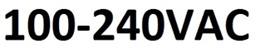 | Supply voltage of the device
 | To turn the power off | 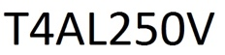 | A fuse
 | Manufacturer |  | Enter a value
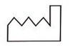 | Date of manufacture |  | Serial number of the device
 | It is disposed as used electronic equipment |  | CLASS II  IEC 60417-5172

GENERAL REVIEW
  - INTENDED USE
Medical device BIOL can be used in clinical practice for therapy with low-intensity electromagnetic waves, clearly defined shape and frequency (100-1500MHz). Treatment is based on the restoration of damaged areas of the cell membrane and inhibition of the frequencies of pathological wave processes in the body. The medical device is designed to prevent the formation of fibrous tissues and reduce the existing fibrous formations, normalize the functioning of the immune system, treat and prevent viral diseases as part of complex therapy, reduce the duration of the postoperative and rehabilitation period, relieve pain, treat prostate pathologies.

  - RECOMMENDATIONS FOR USE
The device is designed to modulate the patient's immune system, treat viral diseases, reduce the duration of the postoperative rehabilitation period and relieve pain.
Individual use of the device is recommended by a doctor, who determines the duration and number of sessions, as well as monitors the course of treatment according to the patient's clinical tests.
The device is recommended for use in medical, treatment-and-prophylactic, sanatorium and outpatient institutions.
RECOMMENDED USE OF THE MEDICAL DEVICE as a part of complex therapy and rehabilitation after a stroke / acute disturbance of cerebral circulation;
after COVID-19;
subacute and chronic inflammation: prostatitis, benign prostatic hyperplasia, pneumonia, bronchitis, etc.;
poorly healing wounds and immune deficiency;
injuries and diseases of the joints and spine of various origins: arthritis, osteoarthritis, Para synovitis, epicondylitis, bursitis, back pain, sprains, bruises, myositis, tenosynovitis, etc.;
diseases of the cardiovascular system: primary and secondary hypertension, rheumatism and more;
diseases of the nervous system: splash, radicular syndrome, vibration disease, etc.;
inflammatory tissue diseases: mastitis, postoperative infiltration, strokes, etc.

Scope | Recommended session duration | Recommended quantity of sessions
Modulation of the patient's immune system: restoration of the body's natural immunity. | 120 min  Depending on the patient's condition, the time of therapy can be extended as prescribed by a doctor or shortened. | 10 sessions in a row, one session daily, then a break of 7-10 days.  A repeat course may be prescribed by a doctor.
Reduction of the rehabilitation period after surgery | 60 min in therapy mode.  Depending on the patient's condition, the time of therapy can be extended as prescribed by a doctor or shortened.  The next day 20 minutes | 10 sessions in a row, one session daily, then a break of 7-10 days.  A repeat course may be prescribed by a doctor.
Reduction of pain (back, neck, rheumatic pain), reduction of spasmodic pain. | 60 min in therapy mode.  Depending on the patient's condition, the time of therapy can be extended as prescribed by a doctor or shortened.  The next day 20 minutes. | 10 sessions in a row, one session daily, then a break of 7-10 days.  A repeat course may be prescribed by a doctor.
Reduction of stress and nervous tension, prevention and prevention of colds and viral diseases | 20-30 min  Depending on the patient's condition, the time of therapy can be extended as prescribed by a doctor or shortened. | 10 sessions in a row, one session daily, then a break of 7-10 days.  A repeat course may be prescribed by a doctor.
Reduction of stress and nervous tension, prevention and prevention of colds and viral diseases | 40-60 min  Depending on the patient's condition, the time of therapy can be extended as prescribed by a doctor or shortened. | 10 sessions in a row, one session daily, then a break of 7-10 days.  A repeat course may be prescribed by a doctor.
Rehabilitation after stroke | 120 min  Depending on the patient's condition, the time of therapy can be extended as prescribed by a doctor or shortened. | 10 sessions in a row, one session daily, then a break of 7-10 days.  A repeat course may be prescribed by a doctor.
Injuries and diseases of the joints and spine of various origins | 120 min  Depending on the patient's condition, the time of therapy can be extended as prescribed by a doctor or shortened. | 10 sessions in a row, one session daily, then a break of 7-10 days.  A repeat course may be prescribed by a doctor.
Subacute and chronic inflammatory diseases, diseases of the cardiovascular system, diseases of the nervous system, diseases of the respiratory and auditory organs without purulent process, inflammatory skin diseases | 120 min  Depending on the patient's condition, the time of therapy can be extended as prescribed by a doctor or shortened. | 10 sessions in a row, one session daily, then a break of 7-10 days.  A repeat course may be prescribed by a doctor.

  - CONTRAINDICATIONS
Proper examination and diagnosis must be performed, before starting treatment with the device. Please keep up to date with the latest developments and medical publications on devices with low-intensity electromagnetic radiation for detailed information on contraindications and side effects not known at the time of the device's manufacture. Contraindications listed in this section are given at the time of writing of the Instruction. No claims regarding the completeness of this list of contraindications are accepted. Before carrying out the procedures, a medical specialist should be convinced of the expediency of using this procedure, the responsibility for which he bears personally.

The use of the device is contraindicated if a patient has the following signs or pathologies:
- Bleeding, risk of bleeding and blood clotting disorders (haemophilia, haemorrhage, haemorrhoids and ulcers with the risk of bleeding, open wounds and injuries, etc.);
- Severe arterial obstruction (III and IV degree);
- Occlusive vascular diseases, such as obliterating arteriosclerosis and thromboangiitis obliterans (Buerger disease), in which organic occlusion and ischemia are detected;
- Swelling of tissues and the presence of foreign bodies in the affected area;
- Paroxysmal cardiac arrhythmia;
- Epilepsy;
- Gastric ulcer with a complicated course.
- The patient has implantable electronic devices (e.g, heart rate driver (pacemaker), etc.), as well as implantable devices containing metal parts.
- Individual intolerance to the procedure.
Pregnancy is an absolute contraindication to use. Individual intolerance of the procedure and/or discomfort during the procedure is an indication of its cancellation.

  - SIDE EFFECTS
Side effects have not been detected. Adverse effects of using the device are possible in case of neglect of the requirements for contraindications.

WARNINGS AND SAFETY PROVISIONS
  - SAFETY SIGNS ON THE DEVICE
The device is protected by reinforced insulation and has no galvanic connection to
the ground

IP20 | Degree of protection against external influences.

  - WARNINGS AND SAFETY PROVISIONS
 | The user must have the proper technical and medical qualifications and know the user’s manual of this device in order to use this device. All maintenance procedures recommended by the manufacturer must be performed by personnel with appropriate approvals.
 | It is allowed to use the device in medical centers, in rehabilitation and sports medicine centers, SPA centers, massage rooms for adult patients (18 years and older).
 | The operator must inspect the housing of the electronic unit, as well as the power cord to ensure there is no external damage. Operation of the device with a damaged casing or a power cord is prohibited!
This device complies with the requirements of the electrical safety standard EN
60601-1: 2010.
It is necessary to connect the device to the mains supply in accordance with the national electrical safety regulations.
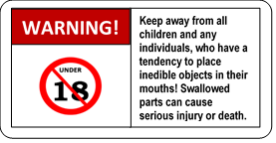 |  | The device must be placed beyond the reach of a patient, especially children
 | Certified and safe materials are used for the device.
 | ATTENTION! Modification of the product is not allowed!
 | CAUTION! To avoid the risk of electric shock, the product must only be connected to a main supply that has a protective ground.
 | Disconnect the device from the power supply, before performing any cleaning or maintenance work. The means of simultaneous electrical separation of the supply circuits of the device from the circuits of the supply network is the mains switch of the device.
 | Connect the device only to a working socket with a rated voltage within the range 100 - 240V 50-60Hz. The location of the device should ensure that there is no tension on the power cord, unhindered connection and disconnection of the power cord from the mains are to be ensured to quick disconnection of the device from the mains in emergency situations.
 | Do not allow humidity to enter the electronics housing. Do not expose the device to dampness, vibration, or shock.
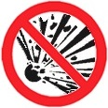 | It is prohibited to use the device in a potentially explosive atmosphere, i.e. in the presence of a mixture of flammable anaesthetic gas with air, oxygen or nitrogen oxide.  It is prohibited to use the device in rooms where flammable and potentially explosive substances are stored or used.
 | Potentially, there is a risk of passing microbes through the surface of the housing of the device. It is recommended to clean it regularly!
 | The patient should be properly located for treatment. It is necessary to monitor a patient's state during the procedure.
 | It is allowed to use the device only after studying this IFU!
 | It is prohibited to use the medical device in an oxygen-rich environment.

  - MEASURES TO PREVENT DAMAGE OF EQUIPMENT AND THE DEVICE
Connect the device to the mains through a circuit breaker with the characteristic "C" and a rated current of not more than 6A.
The placement of the device must ensure uninterrupted connection and disconnection of the power cord from the mains. Avoid the situation when the power cord is under the feet of a user or patient! Do not allow the mechanical load on the power cable and the device’s enclosure (compression, stretching, stepping on, etc)!
It is prohibited to cover the device during operation.
It is forbidden to disconnect the device during operation from the mains network.
This device complies with the requirements of electrical safety and EMC (IEC 60601-1:2024 SER). As a rule, the level of emitted electromagnetic interference is not sufficient to disrupt the operation of most devices. However, it should exclude the operation of the device in close proximity to sensitive equipment. It is recommended to place the device no closer than 3m to such equipment.
The device must be stored in a place protected from the direct sunshine.
It is necessary to exclude contact of the device with different solvents, gasoline, kerosene and other substances that can destroy or damage the device housing.
It is forbidden to install the device on slippery surfaces to prevent the device from falling.

BRIEF DESCRIPTION OF THE DEVICE
The therapeutic action on tissues and inner organs of a patient by low intensity electromagnetic field with frequency band of 100-1,500 MHz
Emitted electromagnetic waves result have the oscillatory effect in the human body, thus stimulating activity of the physical and chemical processes in the body. The penetrating ability of UHF waves in tissue is 8-11 cm on average. Skin and subcutaneous fat thickness have no significant influence on the reflection and absorption coefficients of the waves.

  - FUNCTIONAL DIAGRAM OF THE DEVICE

Studies of the effects of electromagnetic fields (EMF) on living organisms have been conducted since the middle of the last century. Thus, it was found that EMF can affect the biochemical reactions and behaviour of charged molecules near membranes, namely: to create electric fields in conductors, to exert force on moving charge carriers, to change the diffusion rate through membranes, to change valence angles, which affects binding proteins and synthesis of macromolecules, etc.
Studies in the field of molecular biology have established the presence of endogenous bioelectric signals, as well as determine their sources and effects on embryogenesis, regeneration and neoplasms. Ion fluxes and voltage gradients generated by ion channels and pumps are key regulators of cell proliferation, migration, and differentiation. Closed channels have movable folds in proteins, which in turn can be open, allowing ions to pass through the channel, or closed, preventing the passage of ions through the channel.
The uneven distribution of several key ions (Na⁺, Cl⁻, K⁺) between the intracellular and extracellular fluid and their movement across the plasma membrane determines the electrical properties of the membrane. All plasma membranes have a membrane potential, therefore, the membrane potential (Vmem) leads to the distribution of charges across the membrane. Each time the value of Vmem differs from 0 mV, in the positive or negative direction, the membrane is in a state of polarization. The magnitude of the polarization potential is directly proportional to the number of positive and negative charges separated by a membrane. In other words, changes in Vmem cause changes in the movement of ions across the membrane. Trigger events, such as the effect of an exogenous electromagnetic field (EMF), the frequencies of which resonate with endogenous EMFs, also cause changes in membrane permeability.
Changes in membrane potential regulate the proliferation of progenitor cells, stem cells and regenerative systems, as well as the efficiency of cytotoxic T lymphocytes.
Other studies have shown that stress gradients were not just membrane potentials but also specific signals for key metabolic processes in regenerative wound healing. These signals determine the path of cell migration, forming stress gradients between the intracellular and extracellular environment. Voltage gradients are localized DC electric fields that turn on and off at different stages of development. They spread to the extracellular space, as well as into the cytoplasm of one or more cells connected by slit compounds. These gradients can penetrate the cell membrane, the cytoplasm and even the membrane of the cell nucleus by signal transmission, with the EMF signal being received through receptors on the cell surface and then treated with G-proteins that bind receptors to effectors such as ion channels. It is known that these signaling processes have a correlation between the presence of EMF gradients and the cellular response.

In the process of technical implementation of the BIOL device, these features were taken into account and thus were determined before the application of the frequency range of meter and decimeter waves.

Functional diagram of the device BIOL (Pic. 1) includes radio frequency generator modules and module of emitters, operation mode processor, sensor of emission, control panel and power supply unit.
Generator modules are designed to generate radio-frequency signals, amplify those signals and match them to the radiating aerials, which are located in the radiator module. The signal is generated by frequency synthesizer microchip. The centre radiated frequency value, deviation and the law of frequency variation are defined by the controller.
Control over the generator module controllers is carried through control bus of the operation mode processor. The switch-on sequence of the generators, session time, centre frequency values and the law of their variation, as well as other parameters, are set according to the chosen operation mode.
Модуль генератора
Модуль генератора
Control bus
Power Supply Unit
Sensor of emission
RFA
V/C
Controller
Frequency synthesizer
Module of emitters
220 V

Control panel
Operation mode processor

RFA
V/C
Controller
Frequency synthesizer
Generator module

Picture 1 Functional Diagram of the device BIOL

BEFORE USING THE DEVICE BIOL
  - THE LIST OF PREPARATORY ACTIONS
Before using the device BIOL, it is necessary to do the following:
- If you charge the batteries in the device, make sure that the power supply is used with protective grounding; that the mains voltage is in the range of 100 - 240V, 50 - 60 Hz. The BIOL device is designed to be connected to type F (Schuko) sockets (European socket with grounding CEE 7/4, DIN 49440 standard). To connect the device to other types of sockets, an appropriate adapter is required; in any case, the presence of protective grounding in the socket is mandatory!
- Ensure the presence and storage of 70 - 96% water-alcohol solution to clean the device.
- Ensure the presence and storage of medical alcohol wipes or cotton pads for cleaning the device.
- Ensure the presence and storage of wet wipes for a screen that does not contain alcohol to clean the display of the device BIOL.
- Organize the workplace of the operator so that the device is placed on a solid, smooth, dry and not slippery surface to comply with the measures listed in paragraph 2.3.
- Remove the device from its packaging. Check if there is no damage to the housing of the device and the power cord. Check that the power switch is in the position "Off" (the button on the front panel is in the "not pressed" position.)
- Connect three external antennas to the device and fasten them with the antenna holder.
- Six LADDA AA batteries rechargeable at 2450 mA/h or more can power the device. Make sure the batteries are inserted correctly into the device; they may not be included in the delivery.
Connect the power supply to the power connector on the panel of the electronic unit, and plug the power cord into a power outlet.
  - THE OPERATOR’S QUALIFICATION
The device BIOL is intended for use by the operators having special knowledge in the field of application of this device and trained about the proper application of the device, as well as the operators who have practical skills in working with similar medical equipment.
The operator should have main physical and cognitive abilities, such as sight, hearing and literacy. A tremor in hands of the operator is an obstacle for the device use, as the parameters of a session could not be set.
Besides, the operator must take into account the manufacturer's recommendations (Chapter 1, item 1.2 "Indications for use" and item 1.3 "Contraindications") to be aware of the latest developments and medical publications for detailed information on contraindications and side effects, not known at the time of manufacture.
The operator has to take the appropriate training regarding the correct operation of the device before working with it:
- Intended use of the device with practical exercises;
- The mechanism of action and function of the device;
- Setting up of the working modes;
- Recommendations for use of the device;
- Contraindications and side effects;
- An explanation of alerts in all modes of operation;
- Method of functional verification of the device.
Further recommendations for the scope of training may vary depending on the country. Please contact your local representative of SC LLC «LABORATORY OF SYSTEMIC BLOOD RESEARCH «BIOPROMIN» for detailed information on training.

OPERATION OF THE DEVICE BIOL
In a process of the device application, the operator must be in a satisfactory physical and emotional state (after a sufficient rest), should not take in psychotropic substances, analgesics, opiates, sleeping pills, drugs or alcohol for at least 48 hours before performing procedures using the device.

  - A PATIENT’S LOCATION
The patient should be at a distance of 1.5-2 meters from the device from any side in a convenient position (sitting, lying, etc.).
1.5m
1.5m
0.5m
0.5m
WORK ZONE
the back panel of the device
BIOL
front panel of the device
WORK ZONE
  - AN OPERATOR’S LOCATION
The operator is not recommended to be within a radius of 3m around the device during the treatment session.
  - SWITCHING THE DEVICE ON
    - Connect three external antennas to the device and fasten them with the antenna holder.
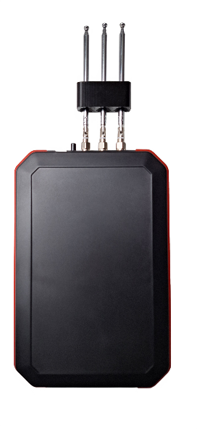
    - Make sure you can rotate all three antennas upward to an angle of approximately 110°
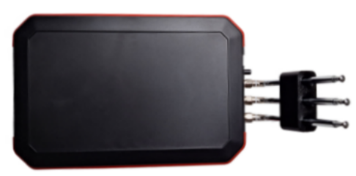
    - Extend all antennas to their full length.
    - If the batteries are low, connect the power supply. The power supply connector is located on the front panel of the device. When the power supply is connected and the batteries are low, the red LED will light up.
    - Press the power button on the front panel of the device:
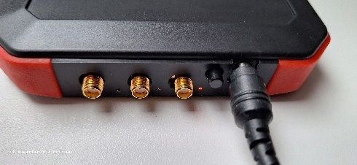
After turning on the power, the green LED blinks briefly once every 2 seconds.

    - The device is ready for use. The device is controlled by the software using the BLUETOOTH BLE.

BIOL SOFTWARE
The Progressive Web Application BIOL (PWA BIOL or BIOL) is used to control the BIOL device. PWA BIOL works under different operating systems: Windows, macOS, Linux, Unix, iOS using EDGE, CHROME, VIVALDI, BLUEFLY browsers.
PWA BIOL for iOS works exclusively under the BLUEFLY browser. For all other OS, use EDGE, CHROME, VIVALDI browsers

.

6.1 INSTALLING THE PWA BIOL.
To install the application on the Windows desktop, use the browser. In the search bar, type the following link: biol.pp.ua
Run CHROME | 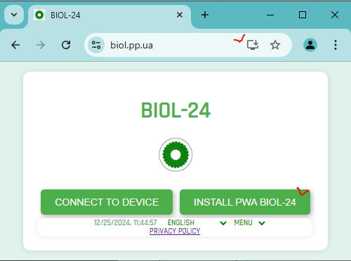
Step 1 | 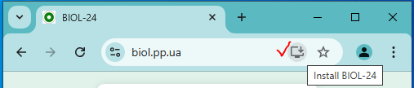
Step 2 | 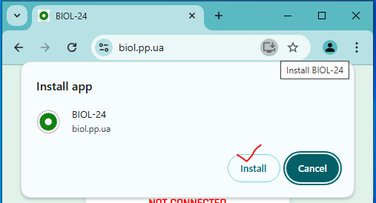
Step 3 | 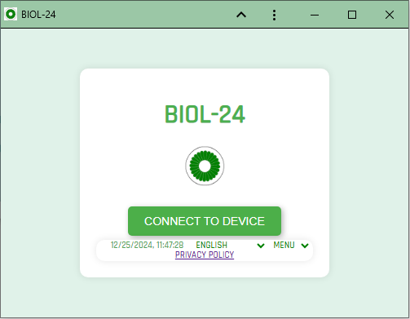
Step 4 | 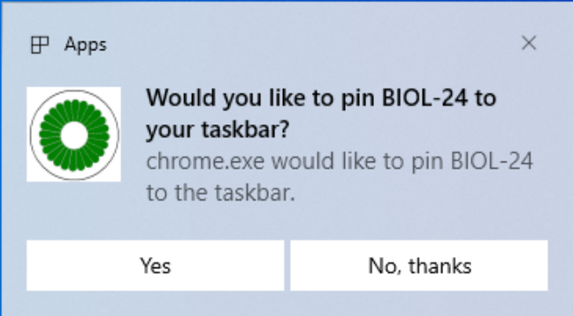
Use icons | 
Use icons | 
Browser EDGE | 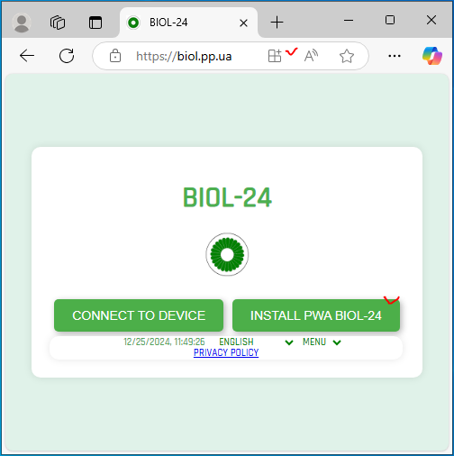
Step 1 | 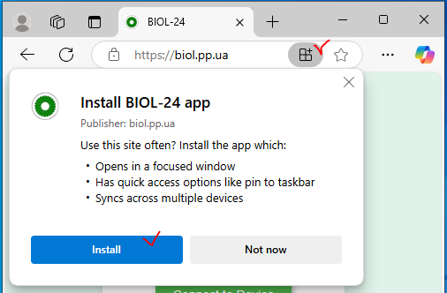
Step 2 | 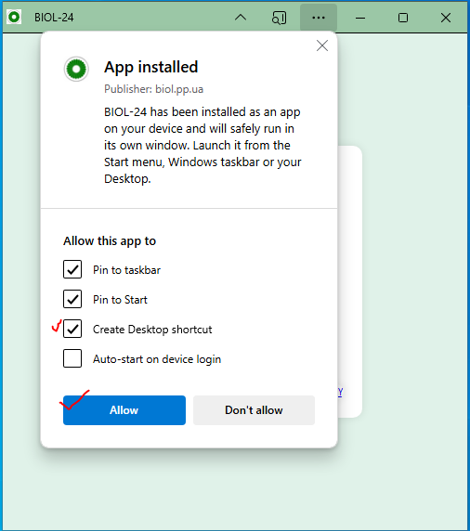
Step 3
Step 4 | 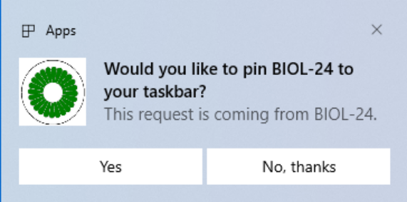
Use icon | 
Use icon
Browser VIVALDI | 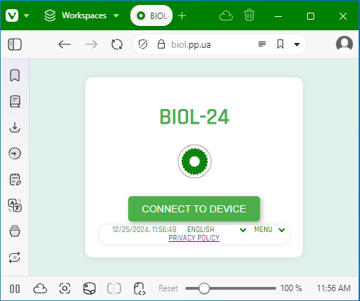
Step 1  Right-click on the application tab. A drop-down menu will appear. | 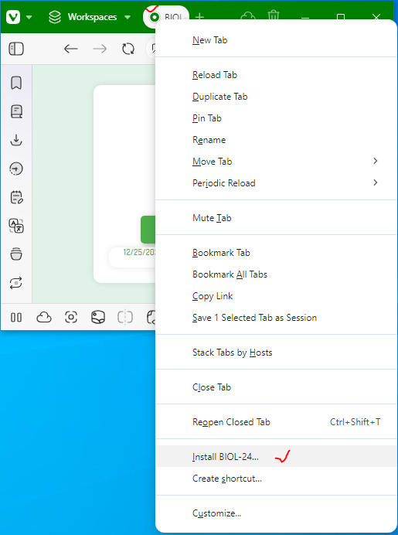
Step 2 | 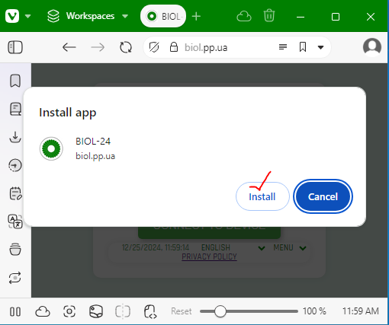
Step 3
Step 4 | 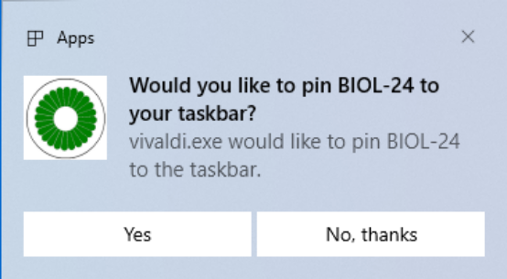
Use icon
Use icon

INSTALLING SOFTWARE FROM GOOGLE PLAY

To install the software from GOOGLE PLAY, use the link or use the QR code. | 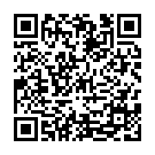

WORKING WITH PWA BIOL
After installing the PWA BIOL application, there will be icons on the desktop of your gadget and in Taskbar (for Windows). Click on any of them. The application will open on the desktop screen.
In the lower panel of the PWA BIOL application, you can select the interface language and read the Privacy Policy.
Click the ‘Connected to Device’ button and connect to the BIOL device. | 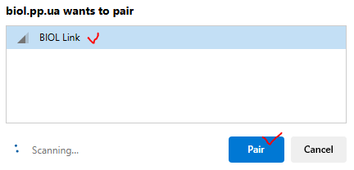
The PWA BIOL will display 5 buttons.  Buttons ‘20 min’, ‘90 min’, ‘120 min’ for automatic selection of the session duration.  Button ‘Custom’ for selecting an arbitrary session duration.  Button ‘Reset’ to disconnect from the BIOL device and then close the PWA BIOL.  You can also see the serial number of the device and the name of the manufacturer.  The appliance will enter programme standby mode. The green LED on the front panel of the appliance will be on continuously. | 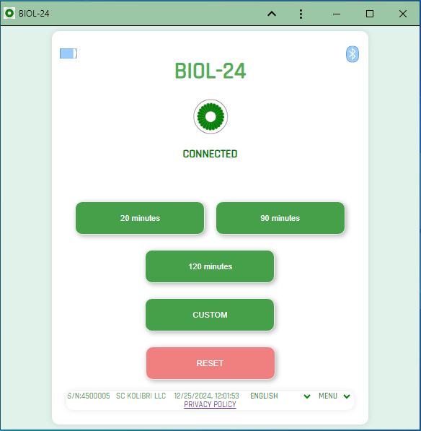
Press the ‘20 min’ button.  The device will switch to the emissions mode. The central logo starts to spin. The green LED on the front panel of the device will start blinking, namely, 2 seconds on and 2 seconds off. The countdown will start on the PWA BIOL meter.  In 30 seconds after the BIOL device switches to emissions, the battery charge monitoring of the battery installed in the device will start. The information will be displayed at the top right.  You can end your session early. To do this, use the ‘Stop’ button. | 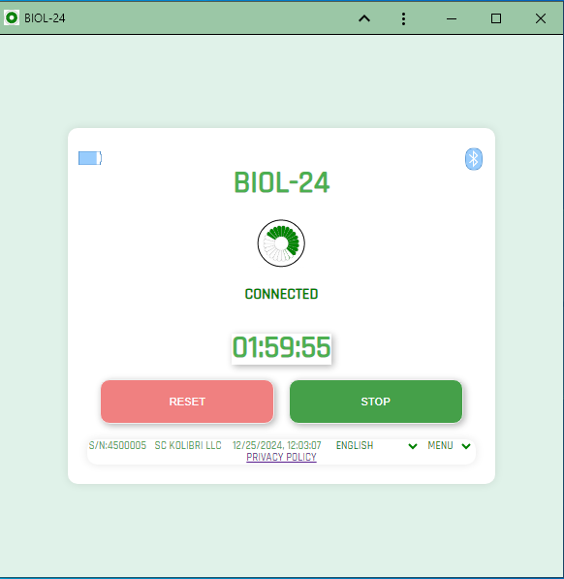
At the end of the session or after pressing the ‘Stop’ button, the PWA BIOL will enter the standby mode to select the next emissions session.  The appliance will enter programme standby mode. The green LED on the front panel of the appliance will be on continuously.  To select a user application, use the Custom button. | 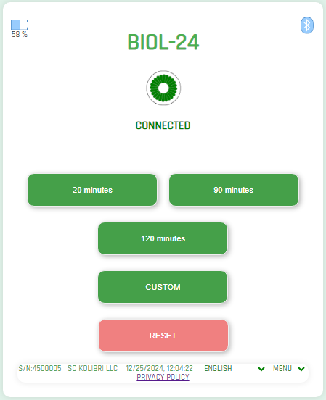
Enter the number of minutes you need in the settings field (for example, 80). It is recommended to enter numbers in multiples of 4, and in the range from 4 to 180 minutes. Click the ‘Run custom programme’ button. | 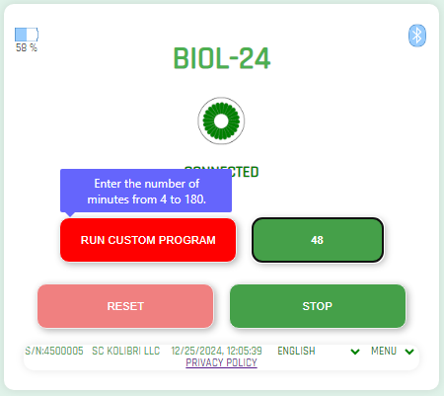
The countdown will begin. The emissions procedure will end when the time is up.  NOTE: The countdown timer appears after a few seconds. | 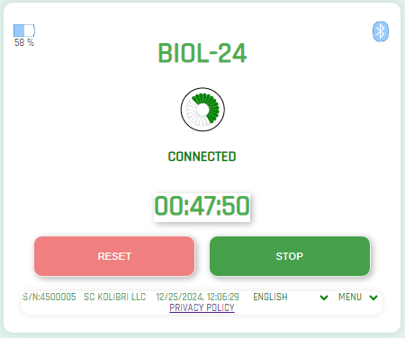
Use the ‘Reset’ button to disconnect the PWA BIOL from the BIOL.
The PWA BIOL is disconnected from the BIOL.  The appliance will go into standby mode. The green LED on the front panel of the device will blink briefly and go off for 2 seconds.  You can switch off the BIOL. Use the button on the front panel of the BIOL. | \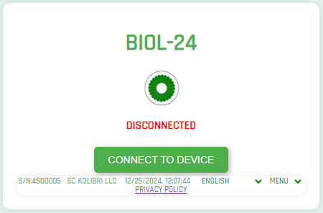
The application interface can be displayed in 28 languages. Select the appropriate menu item. | 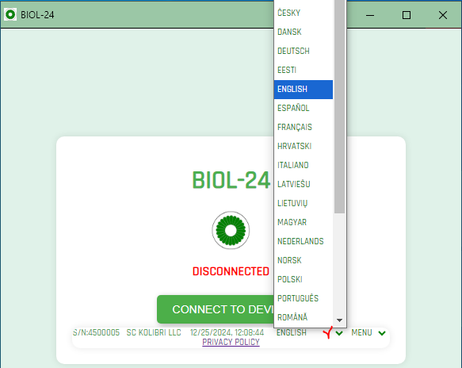
To get more information about the PWA application, use the ‘ABOUT’ menu item | 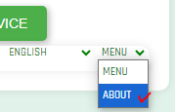

A short video tutorial on how to use the BIOL medical device management application. The application is installed and runs on all popular OS: WINDOWS, iOS, macOS, ANDROID, LINUX, and UNIX. We recommend using the following browsers to install or use the application: CHROME, EDGE, VIVALDI for WINDOWS, macOS, ANDROID, LINUX, UNIX and BLUEFLY if you use iOS.  Your mobile gadget or computer must have a BLUETOOTH BLE enabled.  Switch on your BIOL medical device and watch this video. Now, you can enjoy easy and convenient remote control of your medical device. | LINK
 | 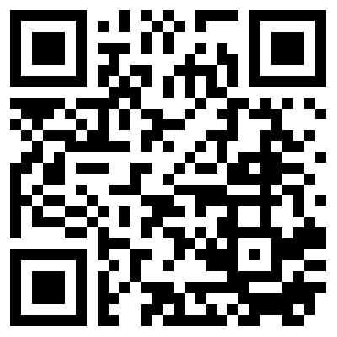

SHUTDOWN AND STORAGE
To properly switch off the BIOL, press the power button on the front panel on the right. You can then disconnect the power supply. Fold the external antennas to their minimum dimensions.
If you wish to transport the BIOL, remove the holder from the antennas, disconnect the antennas from the device and place the device in the portable protective case.

MAINTENANCE OF THE DEVICE
  - CLEANING
Regular cleaning of the device ensures its reliable and trouble-free operation.
Disconnect the device from the mains before cleaning and/or repairing it.
In general, the external cleaning of the device body is carried out depending on the frequency of use of the device.
All parts that come into contact with the operator should be wiped with medical alcohol wipes or cotton pads moistened with 70-96% water-alcohol solution.
It is very important to avoid getting liquids inside the device.

  - MAINTENANCE AND SAFETY CHECK
Preventive maintenance is not necessary. However, regular maintenance can help identify possible defects at an early stage and thus increase safety and extend the life of the device.
It is recommended to perform functional checks and safety checks of the device at least once a year. If the national safety regulations for medical devices require a more frequent periodicity of tests and inspections, it is necessary to follow national regulatory documents. Functional and safety checks are carried out at the producing factory or authorized service centres.
  - DISPOSAL AND ENVIRONMENTAL PROTECTION

In case of failure and impossibility of further use of the device BIOL, it is disposed of as used electronic equipment. Please dispose of the apparatus in accordance with the current regulations in your country.
PACKAGING DISPOSAL: Packaging components (cardboard, expanded polystyrene, etc.) are classified as solid waste and therefore they can be easily recycled by using recycling processes. Before sending the components to special recycling centers, it is necessary to check local regulations in that regard in order to comply with them fully.
PRODUCT DISPOSAL: The device BIOL consists of various materials. Nevertheless, all of them (metal, plastic, electrical conductors, printed circuit boards, chips, etc.) do not contain hazardous substances and they can be sent to special recycling centres in the same way as electronic equipment. Before sending the components to special recycling centres, it is necessary to check local regulations in that regard in order to comply with them fully.
  - REPAIR
Only personnel who has an appropriate authorisation from the company Scientific company LLC «LABORATORY OF SYSTEMIC BLOOD RESEARCH «BIOPROMIN» can carry out repairs of faulty devices BIOL. Only the spare parts indicated by Scientific company LLC «LABORATORY OF SYSTEMIC BLOOD RESEARCH «BIOPROMIN» must be used for that. The personnel with appropriate authorisation may include Scientific company LLC «LABORATORY OF SYSTEMIC BLOOD RESEARCH «BIOPROMIN» staff and technician specialists of sales representatives who have permission from Scientific company LLC «LABORATORY OF SYSTEMIC BLOOD RESEARCH «BIOPROMIN».

SHELF-LIFE AND LIFETIME OF THE DEVICE
Considering the characteristics of similar equipment on the market, as well as the actual period of the device BIOL being marketed, the following lifetime period is established for the device, with the obligatory compliance with conditions of packaging, storage, transportation and use:
• 5 years or 2 500 working hours - for the electronic unit of the BIOL;
The probability of failure of the components and accessories of the device increases after exceeding of the lifetime.
Considering the characteristics of similar equipment on the market, as well as the lifetime of the MD BIOL, the shelf-life for the MD BIOL and its parts/accessories, with mandatory fulfilment of the terms of packaging, storage, transportation and use, set forth in this IFU, has been established as follows:
SHELF-LIFE:10 years. During a long period of storage, cells/batteries should be maintained every 90 days (to keep the lifetime of the cell): the standard method of the charge-discharge cycle should be applied.
The LIFETIME and SHELF-LIFE can be prolonged after testing the device by the manufacturer or the authorized service center on correct operability.
 | Batteries have their own life cycles: 300 cycles (approximately 1 year of operation). One cycle refers to one charge period and then one discharge period. So, the life cycle means that after 300 times of discharge-charge, the cell capacity will be reduced to 80% of the rated one.  Therefore, if the time of working of the MD ANALYZER in wireless mode becomes much shorter than usual, the battery cell life is at an end.  Please ask your distributor/manufacturer for replacement. See additionally Chapter 22.
 | Replacing the battery with insufficiently trained personnel can lead to danger! (temperature rise, fire, explosion). It is forbidden to replace the battery on its own.
After reaching the term, the medical devices BIOL are to be checked by the manufacturer or an authorized service center to confirm their workability and correct operation. The shelf life of the device can be extended by the manufacturer after inspection.

COMPLETION AND RECOMMENDED SERVICE MATERIALS
The device BIOL complete set includes the following:
Name of a part |  | Quantity
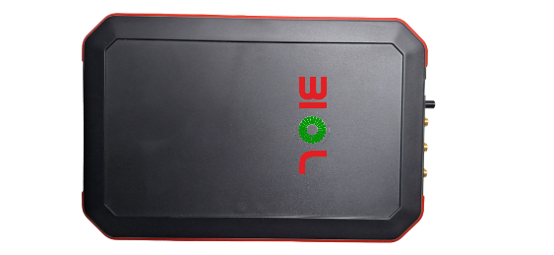 | The unit of MD BIOL | 1
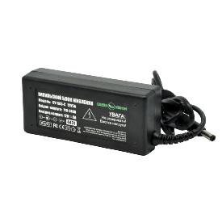 | Power supply unit | 1
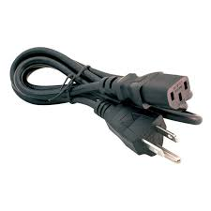 | Power cable | 1
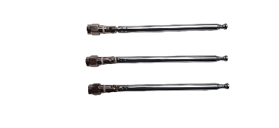 | Antennas | 3
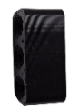 | Antennas holder | 1
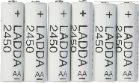 | LADDA AA Battery rechargeable 2450 mA/h | 6
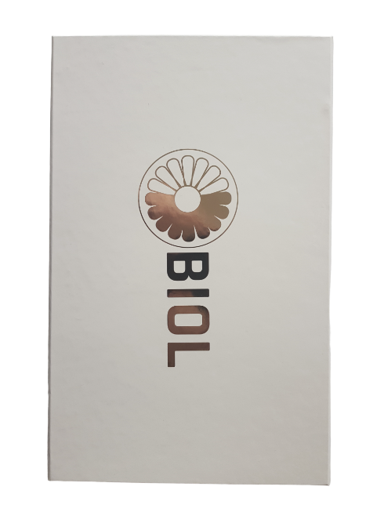 | Package box | 1
IFU (offered in electronic form/available on web) |  | 1

  - RECOMMENDED MATERIALS FOR SERVICE AND MAINTENANCE
It is recommended to use the following items for cleaning:
- 70 - 96% water-alcohol solution and cotton pads;
OR
- Medical alcohol wipes

TECHNICAL DESCRIPTIONS

  - CLASSIFICATION
By the way of protection against electric shock, the device belongs to the class I with a working part of type BF.
The degree of protection against external influences is IP20.
The operating mode of the electronic unit of the device is long.
Item | Model | Class | Reference
Low-Intensity  VHF-UHF  Therapy Apparatus  BIOL | MD BIOL | IIa | Active Medical Device of Class IIa, according to the ANNEX VIII, Chapter I DURATION OF USE: “Transient”  ANNEX VIII, Chapter I, 2.4 (‘Active therapeutic device’ means any active device used, whether alone or in combination with other devices, to support, modify, replace or restore biological functions or structures with a view to treatment or alleviation of an illness, injury or disability.),  Chapter III 6.1 Rule 9 of the REGULATION (EU) 2017/745 OF THE EUROPEAN PARLIAMENT AND OF THE COUNCIL All active therapeutic devices intended to administer or exchange energy are classified as class IIa
Low-Intensity  VHF-UHF  Therapy Apparatus  BIOL | MD BIOL | IIa | Active Medical Device of Class IIa, according to the Annex IX Sect. I clause 1.5, 3.1 Rule 9 of the Directive 2007/47/EC of the European Parliament and the Council amending Council Directive 93/42/EEC concerning medical devices  TR-752, ANNEX II, Chapter 1, 2) Active medical device for therapy - any active medical device used alone or in combination with other medical devices to maintain, modify, replace or restore biological functions or structures to treat or alleviate illness, injury or disability;  ANNEX II, Chapter 2 DURATION OF USE: «Transient», ANNEX II, Chapter 17 All active therapeutic medical devices intended for the transmission or exchange of energy are in Class IIa, Все активные медицинские изделия для терапии, предназначенные для передачи или обмена энергией, относятся к классу IIа.

  - TECHNICAL DATA
The electronic unit | Technical characteristics
Input voltage of the network | 100-240 VAC 0.35-0.2 A
Network frequency | 50/60 Hz
Output voltage | 12-15V
Output current (A) | 5A
Output power (W) | 60W
LADDA AA Battery rechargeable | 2450 mA/h  Battery Cell Composition NiMH
Telescopic antenna | Frequency range 40 MHz-6 GHz  Diameter of the thickest section: 5.2 mm  Total length folded: 95 mm  Total length unfolded: 290 mm (5 sections unfolded)  Connector: SMA-male (pin).
Electricity consumption | max. 15V.A
Total output power | 0.1 W
The ambient temperature during the operation process | 5 – 40 °C
The ambient temperature during a  storage and transportation | -25 ° C without relative humidity control + 70 ° C with relative humidity control  This class 7K3 as described in IEC/TR 60721-4-7:2001
Ambient air pressure | 700-1060 hectopascal
Air humidity | 15%-93%, without condensation
Total weight | 2,0 kg.
Net weight | 0,5 kg.
Dimensions of the device  BIOL (D / W / H) | 191x126х25 mm.
Protection against water penetration | IP20
Software version | V.1.02

The device power supply unit is a means of simultaneous electrical separation of the BIOL device power supply circuits from the mains power supply circuits.
The temperature of all surfaces of the medical device does not exceed 40 ± 0.5°C

As the BIOL has a battery for wireless mode of operation, the following technical features shall be considered:
Typical Application Features | NiMH vs. Lithium Primary | NiMH vs. Alkaline
Rated Voltage | 1.25V vs. 1.5V | 1.25V vs. 1.5V
Discharge Capacity | NiMH will not last as long as primary lithium (single cycle) | NiMH lasts longer in high drain, less in light drain devices than alkaline
Recharge Capability | Several hundred cycles for NiMH, N/A for lithium primary | Several hundred cycles for Ni-MH, N/A for alkaline primary
Discharge Voltage Profile | Both relatively flat discharge | NiMH is flat vs. sloped for alkaline
Self-Discharge Rate | NiMH retains 50-80% @ 12 months Lithium retains >90% @ 15 years | NiMH retains 50-80% @ 12 months Alkaline retains 80% @ 10 years
Low Temperature Performance | Lithium better than NiMH | NiMH better than alkaline
Battery Weight | Lithium is lighter | Alkaline is lighter
Environmental Issues | Recycling options available for NiMH and lithium | Recycling options available for NiMH and some alkaline

 | The battery is replaced by yourself.  We will take no responsibility for any accident when the cell is used under other conditions than those described in this Document. We will inform, in a written form, the customer of improvement(s) regarding the proper use and handling of the cell, if it is deemed necessary.
 | Batteries have their own life cycles. If the time of working of the BIOL in wireless mode becomes much shorter than usual, the battery cell life is at an end. Please ask your distributor/manufacturer for replacement.
 | In case the battery is damaged, and the fluid leak is detected, avoid the contact with it. If it liquid leaks onto your skin or clothes, wash thoroughly with fresh water immediately. If liquid leaking from the battery gets into your eyes, do not rub your eyes. Wash them thoroughly with clean edible oil and visit a medical professional immediately.
 | Strictly prohibits to use the MD BIOL close to fire or inside of a car where the temperature can reach 60°C and more. Also, do not charge/discharge it in such conditions (it may cause an explosion of the battery cell).
 | Replacing the battery with insufficiently trained personnel can lead to danger! (temperature rise, fire, explosion). It is forbidden to replace the battery on its own.
A specific condition of storage related to the Ni-MH battery.
During a long period of storage, cells should be maintained every 90 days (to keep the lifetime of the cell): the standard method of the charge-discharge cycle should be applied.
Do not store the MD BIOL in wet or cold conditions! Moisture and cold increase the discharge rate of the battery. And under the influence of extremely high temperatures, there is a risk of explosion of the battery.

Minimum requirements to a computer, both for hardware and software, which are enough to use with PWA BIOL
Minimum hardware requirements |  | Minimum software requirements
HDD/SSD | min. 128 Gb (256Gb is preferable) | Operating system
RAM | min. 4 Gb and more | Windows 10 and higher, macOS 10.13 and higher.  Edge 79 and above.  Chrome version 56 and above.  Vivaldi version 5.3 and above.  For the iOS operating system, you can use the Bluefly web browser version 3.9.1 or higher.
Display | min. 5” -55” and more  definition HD, FHD, QHD or more
Bluetooth | BLE
Medical grade computer (or mobile gadget) is recommended for use in combination with the MD BIOL. In any case, the local regulations and requirements regarding computers (or mobile gadget) in medical care institutions must be followed by the user. |  | Any anti-virus software, if installed by the user, must be configured in such a way that the PWA BIOL software is not blocked.

  - TRANSPORTATION AND STORAGE
Transportation and storage of the device BIOL are only permitted in the manufacturer's packaging.
You should avoid shaking and impacting of the package during transportation and storage.
Storage and transportation conditions of the device are the following:
- from -25 ° C (without relative humidity control) up to + 70 ° C (with relative humidity control);
- relative humidity 15% -93% without condensation;
- And also, the absence of aggressive impurities that cause corrosion in the air.
- Storage 7 years.

WARRANTY TERMS
The warranty for the device BIOL is 36 months from the date of sale.
The warranty does not cover cables and fuses.
The manufacturer or the authorized representative provides the free repair of malfunctions or replacement of the device during the warranty period if there is a detection of manufacturing defects or defects in materials. The warranty for such a device does not apply if faults are caused by the user, due to a violation of the operating rules of the device described in this IFU, or the device was misused.
The warranty also does not cover damages caused by the user violating the storage and transportation rules set out in this IFU, as well as the force majeure.
Warranty claims are accepted only on the condition that the device is returned in its complete configuration, in its pure form, without external mechanical damages and traces of disassembly/opening.
Transportation costs and the risk of accidental loss during the delivery of the returned product shall be borne by the customer.
ATTENTION! It is not allowed to make any changes in the design of the device. Any unauthorized opening, repair or modification of the system by unauthorized personnel releases the manufacturer from obligations and responsibility for the safe operation of the device. In this case, the warranty is automatically declared invalid even before the expiration of the warranty period. The warranty is cancelled if the customer has made a modification or made any uncoordinated changes to the software of the device without the written consent of the company Scientific company LLC «LABORATORY OF SYSTEMIC BLOOD RESEARCH «BIOPROMIN».

For all questions regarding the operation of the device, please contact our customer service:
 | Manufacturer:  LLC «LABORATORY OF SYSTEMIC BLOOD RESEARCH «BIOPROMIN» (Biopromin LLC) 02660, Kyiv, Vyzvolyteliv str., 3, office 301  Telephone: +380973423922  email: bioluch@gmail.com |  | Authorized representative in European Union:  ONKOCET Ltd.  47 Pribisova str., 84105 Bratislava, Slovakia, Tel.: +421 (2) 44 64 09 77  e-mail: onkocet@onkocet.eu  URL: www.onkocet.eu

POSSIBLE ERRORS AND MALFUNCTIONS. TROUBLESHOOTING
 | Error / problem | Possible reasons | Indicators / Disposal
Е1 | The device does not turn on | No power supply | -Check the presence of an electrical current in the mains. In case of absence, try again later.  - Check the connection of the power cord to the device and to an electrical outlet.  - Check the network cable for defects if there are any and replace it.
Е1 | The device does not turn on | Completely discharged batteries. | Connect the device to a charger or replace the batteries.
Е2 | 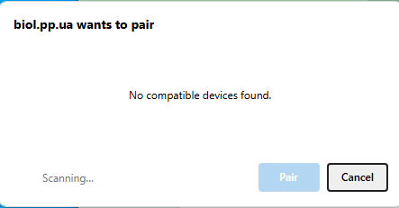 | The BIOL device is switched off. | Switch the BIOL device on.
Е2 | When trying to connect to the BLUETOOTH BLE of the BIOL device, the BIOL Link inscription is not displayed | The BIOL device is switched off. | Switch the BIOL device on.
E3 | Sudden shutdown of a medical device | The disappearance of power supply during the therapy procedure. | Check for mains voltage (mains). Switch on the appliance. Continue the procedure. The total duration of the procedure prescribed by the doctor must be met.
E4 | 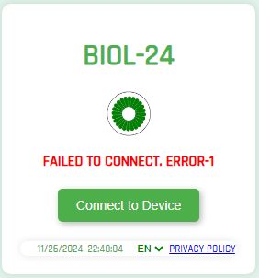  Failed to connect. Error-1 | The attempt to connect to the BIOL instrument failed. | 1. Check that the BIOL is switched on. The green LED on the front of the instrument should be flashing.  2. The BIOL device is defective. Contact a service centre.
E5 | 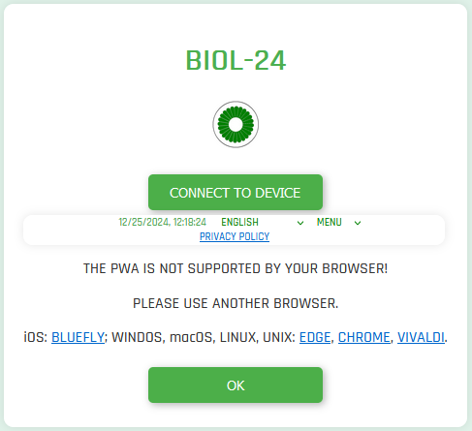 | THE PWA IS NOT SUPPORTED BY YOUR BROWSER! | PLEASE USE ANOTHER BROWSER. iOS: BLUEFLY; WINDOWS, macOS, LINUX, UNIX: EDGE, CHROME, VIVALDI.

CHECKLIST
No | Date of verification / control  Warranty / post-warranty service | Remark | Note | Performer | Sign

PRODUCT ACCEPTANCE PROTOCOL

The device BIOL, No ________ complies with the technical requirements and is completely serviceable.
The warranty period is 36 months from the date of delivery of the equipment.
Date of manufacture “______” ________________ 20___.

(signature) | (First name and Last name)

 | Manufacturer:  LLC «LABORATORY OF SYSTEMIC BLOOD RESEARCH «BIOPROMIN» (Biopromin LLC) 02660, Kyiv, Vyzvolyteliv str., 3, office 301  Telephone: +380973423922  email: bioluch@gmail.com |  | Authorized representative in European Union:  ONKOCET Ltd.  47 Pribisova str., 84105 Bratislava, Slovakia, Tel.: +421 (2) 44 64 09 77  e-mail: onkocet@onkocet.eu  URL: www.onkocet.eu

PACKING LIST

The device BIOL, No ________________ is packed in the company Scientific company LLC «LABORATORY OF SYSTEMIC BLOOD RESEARCH «BIOPROMIN» in accordance with the technical requirements.

Date of packing «_________» ____________________ 20_____.

A packer:
 | Signature | First name and Last name

 | Manufacturer:  LLC «LABORATORY OF SYSTEMIC BLOOD RESEARCH «BIOPROMIN» (Biopromin LLC) 02660, Kyiv, Vyzvolyteliv str., 3, office 301  Telephone: +380973423922  email: bioluch@gmail.com |  | Authorized representative in European Union:  ONKOCET Ltd.  47 Pribisova str., 84105 Bratislava, Slovakia, Tel.: +421 (2) 44 64 09 77  e-mail: onkocet@onkocet.eu  URL: www.onkocet.eu

WARRANTY CERTIFICATE
For repair (replacement) during the warranty period
Medical Equipment - BIOL
Serial number of the device | Date of manufacture
S/N____________ | 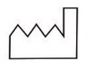  «______» ________________20___
Date of purchase | Signature and seal of the seller
«______» ________________20___

Date of commissioning | Signature
«______» ________________20___

The operating time of the device | Signature
00:00 [hour: min]

The warranty for the device BIOL is 36 months from the date of sale.

The warranty does not cover power cables and fuses.

The manufacturer or his authorized representative performs free repair of malfunctions or replacement of the device during the warranty period, if there is detection of manufacturing defects or defects in materials. The warranty for such a device does not apply if there are faults caused by the user, due to a violation of the operating rules of the device described in this manual, or the usage of the device for other purposes.

The warranty also does not cover damages caused by the user violating the storage and transportation rules set out in this manual, as well as the force majeure.

Warranty claims are accepted only on condition that the device is returned in its complete configuration, in its pure form, without external mechanical damages and traces of disassembly / opening.

Transportation costs and the risk of accidental loss during the delivery of the returned product shall be borne by the customer.

 | Manufacturer:  LLC «LABORATORY OF SYSTEMIC BLOOD RESEARCH «BIOPROMIN» (Biopromin LLC) 02660, Kyiv, Vyzvolyteliv str., 3, office 301  Telephone: +380973423922  email: bioluch@gmail.com |  | Authorized representative in European Union:  ONKOCET Ltd.  47 Pribisova str., 84105 Bratislava, Slovakia, Tel.: +421 (2) 44 64 09 77  e-mail: onkocet@onkocet.eu  URL: www.onkocet.eu

All valid permits and certificates are available on the manufacturer's website https://biopromin.com/

LABELLING

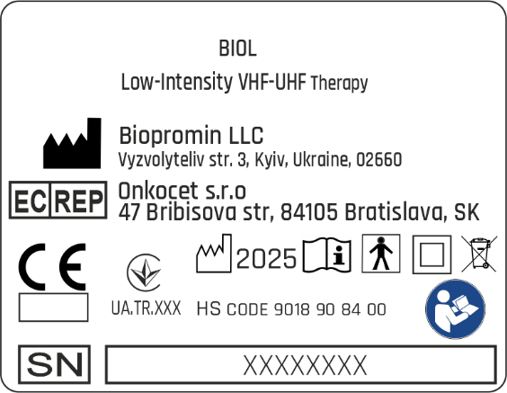 | 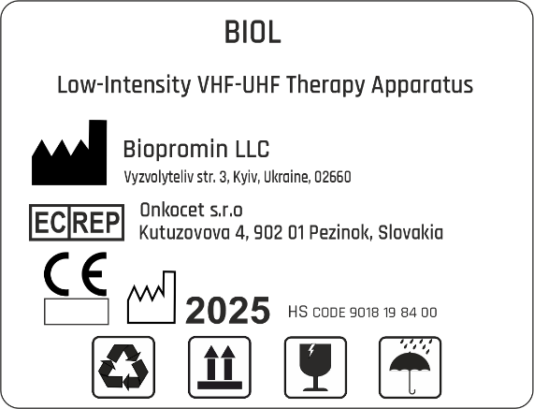

DECOMMISSIONING AND DISPOSAL OF SOFTWARE

To uninstall the software, use the standard features (or functions) of the software environment in which the program is installed.

NOTICE TO THE USER AND/OR PATIENT

Any serious incident that has occurred in relation to the device should be reported to the manufacturer and the competent authority of the Member State in which the user and/or patient is established;

DOCUMENT HISTORY AND VERSION CONTROL

Version | Version Date | Summary of changes | Author | Related documents
1.0 | 2025-01-20 | Created | Team, listed on the title

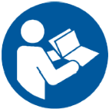 | Read the IFU carefully before using the device!

