

Low-Intensity VHF-UHF
Therapy Apparatus
BIOL
(hereinafter referred to as BIOL or MD BIOL)

PRODUCT DESCRIPTION

CONTENT
1 | GENERAL INFORMATION
 | - GENERAL OVERVIEW (general info, classification and intended use) | 3
 | - The intended patient population(s) and indication for use | 4
 | - The reasonably foreseeable medical conditions for which the system is not to be used (contraindications) | 4
 | - GENERAL DESCRIPTION OF MD BIOL (functioning, capabilities, inputs and outputs) | 5
 | - OPERATING THEORY | 6
2 | TECHNICAL DATA | 7
3 | DESIGN | 9
4 | COMPLETE SET | 9
5 | REFERENCES | 10
6 | DOCUMENT HISTORY AND VERSION CONTROL | 10

Abbreviations and Definitions used:
VHF | Very-high frequency
UHF | Ultra-high frequency
MD | Medical device.

- GENERAL INFORMATION
  - GENERAL OVERVIEW
Medical device BIOL can be used in clinical practice for therapy with low-intensity electromagnetic waves, clearly defined shape and frequency (100-1500MHz). Treatment is based on the restoration of damaged areas of the cell membrane and inhibition of the frequencies of pathological wave processes in the body. The medical device is designed to prevent the formation of fibrous tissues and reduce the existing fibrous formations, normalize the functioning of the immune system, treat and prevent viral diseases as part of complex therapy, reduce the duration of the postoperative and rehabilitation period, relieve pain, treat prostate pathologies.
MD(s) IDENTIFICATION (name, type)
Name: Low-Intensity VHF-UHF Therapy Apparatus BIOL

CLASSIFICATION
Item | Model | Class | Reference
Low-Intensity  VHF-UHF  Therapy Apparatus  BIOL  Прилад низько  інтенсивної  МХ-ДЦХ терапії BIOL  Aparato BIOL de  terapia  VHF-UHF de baja  intensidad | MD BIOL | IIa | Active Medical Device of Class IIa, according to the ANNEX VIII, Chapter I DURATION OF USE: “Transient”  ANNEX VIII, Chapter I, 2.4 (‘Active therapeutic device’ means any active device used, whether alone or in combination with other devices, to support, modify, replace or restore biological functions or structures with a view to treatment or alleviation of an illness, injury or disability.),  Chapter III 6.1 Rule 9 of the REGULATION (EU) 2017/745 OF THE EUROPEAN PARLIAMENT AND OF THE COUNCIL All active therapeutic devices intended to administer or exchange energy are classified as class IIa
Low-Intensity  VHF-UHF  Therapy Apparatus  BIOL  Прилад низько інтенсивної  МХ-ДЦХ терапії BIOL  Aparato BIOL de  terapia  VHF-UHF de baja  intensidad | MD BIOL | IIa | Active Medical Device of Class IIa, according to the Annex IX Sect. I clause 1.5, 3.1 Rule 9 of the Directive 2007/47/EC of the European Parliament and the Council amending Council Directive 93/42/EEC concerning medical devices  TR-752, ANNEX II, Chapter 1, 2) Active medical device for therapy - any active medical device used alone or in combination with other medical devices to maintain, modify, replace or restore biological functions or structures to treat or alleviate illness, injury or disability;  ANNEX II, Chapter 2 DURATION OF USE: «Transient», ANNEX II, Chapter 17 All active therapeutic medical devices intended for the transmission or exchange of energy are in Class IIa, Все активные медицинские изделия для терапии, предназначенные для передачи или обмена энергией, относятся к классу IIа.
INTENDED USE
The device is designed to modulate the patient's immune system, treat viral diseases, reduce the postoperative rehabilitation period's duration, and relieve pain.
Individual use of the device is recommended on the prescription of a doctor who determines the duration and number of sessions and monitors the course of treatment according to the patient's clinical tests.
The device is recommended for use in medical, treatment-and-prophylactic, sanatorium and outpatient institutions.
RECOMMENDED USE OF MEDICAL DEVICE as a part of complex therapy and rehabilitation after a stroke / acute disturbance of cerebral circulation;
after COVID-19;
subacute and chronic inflammation: prostatitis, benign prostatic hyperplasia, pneumonia, bronchitis, etc.;
poorly healing wounds and immune deficiency;
injuries and diseases of joints and spine of different genesis: arthritis, osteoarthritis, synovitis, epicondylitis, bursitis, back pain, sprains, bruises, myositis, tenosynovitis, etc.;
diseases of the cardiovascular system: primary and secondary hypertension, rheumatism and more;
diseases of the nervous system: splash, radicular syndrome, vibration disease, etc.;
inflammatory tissue diseases: mastitis, postoperative infiltration, strokes, etc.
1.2. THE INTENDED PATIENT POPULATION(S) AND INDICATION FOR USE.
The target group is patients of any race and sex over the age of 18 suffering from pathologies for the treatment of which this medical device is intended.
The target group is the medical staff of medical institutions, sanatoriums, and other medical institutions engaged in treating and rehabilitating patients suffering from or suffering from diseases to treat, which this medical device is recommended.
1.3 The reasonably foreseeable medical conditions for which the system is not to be used (contraindications):

Proper examination and diagnosis must be performed, before starting treatment with the device. Please keep up to date with the latest developments and medical publications on devices with low-intensity electromagnetic radiation for detailed information on contraindications and side effects not known at the time of the device's manufacture. Contraindications listed in this section are given at the time of writing of the Instruction. No claims regarding the completeness of this list of contraindications are accepted. Before carrying out the procedures, a medical specialist should be convinced of the expediency of using this procedure, the responsibility for which he bears personally.
The use of the device is contraindicated if a patient has the following signs or pathologies:
• Bleeding, risk of bleeding and blood clotting disorders (haemophilia, haemorrhage, haemorrhoids and ulcers with the risk of bleeding, open wounds and injuries, etc.);
• Severe arterial obstruction (III and IV degree);
• Occlusive vascular diseases, such as obliterating arteriosclerosis and thromboangiitis obliterans (Buerger disease), in which organic occlusion and ischemia are detected;
• Swelling of tissues and the presence of foreign bodies in the affected area;
• Paroxysmal cardiac arrhythmia;
• Epilepsy;
• Gastric ulcer with a complicated course.
• Pregnancy;

1.4. General description of BIOL including its principles of operation, capabilities, inputs and outputs
The BIOL medical device is used for therapy with electromagnetic waves of low intensity, clearly defined shape and frequency (100-1500MHz). Treatment is based on the restoration of damaged areas of the cell membrane and the Inhibition of the frequency of pathological wave processes in the body. The device is designed to prevent the formation of fibrous tissues, reduce existing fibrous formations, normalize the functioning of the immune system, treat and prevent viral diseases as part of complex therapy, and reduce the duration of postoperative and rehabilitation period, pain relief, treatment of prostate disease.

Functional diagram of the device BIOL (Pic. 1) includes radio frequency generator modules and module of emitters, operation mode processor, sensor of emission, control panel and power supply unit.
Generator modules are designed to generate radio-frequency signals, amplify those signals and match them to the radiating aerials, which are located in the radiator module. The signal is generated by frequency synthesizer microchip. The center radiated frequency value, deviation and the law of frequency variation are defined by the controller.
Control over the generator module controllers is carried through control bus of the operation mode processor. The switch-on sequence of the generators, session time, center frequency values and the law of their variation, as well as other parameters, are set according to the chosen operation mode.
Модуль генератора
Модуль генератора
Control bus
Power Supply Unit
Sensor of emission
RFA
V/C
Controller
Frequency synthesizer
Module of emitters
220 V

Control panel
Operation mode processor

RFA
V/C
Controller
Frequency synthesizer
Generator module

Picture 1 Functional Diagram of the device BIOL

1.5. OPERATING THEORY

Studies of the influence of electromagnetic fields (EMF) on living organisms have been conducted since the middle of the last century. Thus, it has been established that EMFs can affect biochemical reactions and the behaviour of charged molecules near membranes (Barnes, 1992), namely: create electric fields in conductors, exert a force on moving charge carriers, change the diffusion rate through membranes, distort bond angles, which affects the binding of proteins and the synthesis of macromolecules, etc.
Research in the field of molecular biology has made it possible to establish the presence of endogenous bioelectric signals, as well as to determine their sources and influence on embryogenesis, regeneration and neoplasms. Ionic fluxes and voltage gradients generated by ion channels and pumps are key regulators of cell proliferation, migration, and differentiation (Levin, 2003). Closed channels have movable folds in proteins that can alternately be open, allowing ions to pass through the channel, or closed, preventing ions from passing through the channel (Sherwood et al., 2005).
The uneven distribution of several key ions (Na⁺, Cl⁻, K⁺) between the intracellular and extracellular fluids and their selective movement across the plasma membrane determines the electrical properties of the membrane (Panagopoulos et al., 2002; Pall, 2013). All plasma membranes have a membrane potential; therefore, the membrane potential (Vmem) leads to charge separation across the membrane (Sherwood et al., 2005). Every time the Vmem value differs from 0 mV, in the positive or negative direction, the membrane is in a state of polarization. The magnitude of the polarization potential is directly proportional to the number of positive and negative charges separated by the membrane. In other words, changes in Vmem cause changes in the movement of ions across the membrane. Trigger events, such as exposure to an exogenous electromagnetic field (EMF), whose frequencies resonate with endogenous EMF, also cause changes in membrane permeability (Funk et al., 2009). Changes in membrane potential, among other things, regulate the proliferation of progenitor cells, stem cells and regenerative systems (Sarah Sundelacruz et al., 2009), as well as the efficiency of cytotoxic T lymphocytes (Jesse A et.al, 2019).
Other studies have shown that voltage gradients were not just membrane potentials, but specific signals for key metabolic processes in regenerative wound healing (Hotary and Robinson, 1992; Levin, 2007; Nuccitelli, 2003). These signals determine the migration path of cells, forming voltage gradients between the intracellular and extracellular environment (Funk and Monsees, 2006). Voltage gradients are localized DC electric fields that turn on and off at different stages of development (McGaig et al., 2005). They spread into the extracellular space, as well as into the cytoplasm of one or more cells connected by gap junctions (Funk et al., 2009). These gradients can penetrate the cell membrane, into the cytoplasm, and even the membrane of the cell nucleus through signal transmission, while the EMF signal is received through receptors on the cell surface, and then processed by G-proteins that bind the receptors to effectors such as ion channels (Ermakov et al. others, 2012). It is known that these signalling processes have a correlation between the presence of EMF gradients and the cellular response (Funk and Monsees, 2006; Sundelacruz et al., 2013).
In the process of technical implementation of the BIOL device, these particular features were taken into account and the frequencies of the meter and decimeter wave ranges were selected.
Back in 1993 (Adey et al.) It was found that a sinusoidal waveform, which creates coherent fields, has a stimulating effect on the immune system. For this, repetitive signals must be generated regularly and must be present for a certain minimum period of time (Litovitz et al., 1993). This resonant coherence is the key to producing larger effects with low thresholds (Panagopoulos et al., 2002). Our studies have shown that a triangular waveform is more efficient than a sinusoidal one due to the uniform distribution of the carrier frequency over the spectrum. Therefore, it is this waveform that is used in BIOL. Depending on the EMF parameters (“what field we are treating”) and the target biological process (“what we are treating”), either stimulation/activation of biochemical processes or inhibition/suppression can occur. And given the effect of EMF on biochemical reactions and the behaviour of charged molecules near cell membranes, the increase in the effectiveness of the drugs used in combination with the treatment with the BIOL apparatus becomes explainable (noted in practice). By changing the permeability of the cell membrane using EMF, we increase the possibility of the formation of an immunological synapse between an infected or oncological cell and cytotoxic T-lymphocytes, which allows the latter to efficiently release perforins¹ and granzymes² into the affected cells. Perforin molecules are incorporated into cell membranes and form pores through which granzymes enter the cell, stimulating the death of affected cells (along the path of regulated apoptosis - the process of programmed cell death).
Initially, the biological activity of the radiation of the medical device BIOL was tested at the Department of Genetics and Cytology of the Kharkiv National University. V.N. Karazin on the cytobiophysical method (2008). The effect of EMF on buccal epithelial cells in vitro was studied at different exposure times on donors. The normalizing effect on the bioenergetic properties of the cell nuclei of native human epithelial cells was reliably established, which made it possible to draw conclusions about the healing effect of EMF radiation.
The BIOL device was clinically tested at the Kyiv Regional Hospital No. 2 (2009) for patients aged 17-94 with the following diseases: intercostal neuralgia, osteochondrosis, rhinolaryngitis, rhinosinusitis, osteoarthritis, rhinitis. The results showed an improvement in physical condition in 80% of patients (a 40% decrease in pain syndrome and a 20% decrease in clinical manifestations of upper respiratory tract diseases) and in 20% no changes in the course of the disease were observed.
In 2009, for 128 patients of the sanatorium "Ukraine" (Simferopol, Crimea), the BIOL device was used as part of the complex therapy of hypertension of the II-III degree (of which, with a concomitant diagnosis of chronic ischemic heart disease (CHD), angina pectoris - 125, conditions after arriving cerebral circulation disorders - 3). A reliable therapeutic effect was obtained, confirmed by hemodynamic parameters and laboratory studies. More than 50% of patients noted a significant improvement in well-being, a decrease in the number of angina attacks and an increase in the action of nitrates (cardiket, nitroglycerin, isoket).
In 2011, in several research centres in Europe, the BIOL device was used for patients with the following diseases (21): prostate adenoma, breast cancer (with and without metastases), lung and colon tumours (adenocarcinoma), and squamous cell carcinoma of the larynx. All patients noted an improvement in the quality of life and a significant reduction in pain. In 4 patients, the state of the tumour remained unchanged (did not improve but did not worsen). The remaining 17 patients showed a decrease in tumours by an average of 15% (10-18%), and in patients with metastases, a decrease in the degree of metastasis (in one of the patients, metastases disappeared).
In 2017-2018, BIOL was used in Taiwan for 3 patients with nasopharyngeal carcinoma, ankylosing spondylitis and colorectal cancer. After a year, all patients showed regression of the disease (according to CT data) and an improvement in the quality of life.

Note 1: Activated killer T cells kill cells with a foreign antigen, to which they have a receptor, by inserting perforins (proteins that form a wide, non-closing opening in the membrane) into their membranes and injecting toxins (granzymes) inside.
Note 2: Granzymes are serine proteases released by cytoplasmic granules of cytotoxic T cells and natural killer (NK) cells. They induce programmed cell death (apoptosis) in the target cell, thereby eliminating cells that have become cancerous or infected with viruses or bacteria. Granzymes also kill bacteria and inhibit viral replication. In NK cells and T cells, granzymes are packed in cytotoxic granules with perforin.

- TECHNICAL DATA

The electronic unit | Technical characteristics
Input voltage of the network | 100-240 VAC 0.35-0.2 A
Network frequency | 50/60 Hz
Output voltage | 12-15V
Output current (A) | 5A
Output power (W) | 60W
LADDA AA Battery rechargeable | 2450 mA/h  Battery Cell Composition NiMH
Telescopic antenna | Frequency range 40 MHz-6 GHz  Diameter of the thickest section: 5.2 mm  Total length folded: 95 mm  Total length unfolded: 290 mm (5 sections unfolded)  Connector: SMA-male (pin).
Electricity consumption | max. 15V.A
Total output power | 0.1 W
The ambient temperature during the  operation process | 5 – 40 °C
The ambient temperature during a  storage and transportation | -25 ° C without relative humidity control + 70 ° C with relative humidity control  This class 7K3 as described in IEC/TR 60721-4-7:2001
Ambient air pressure | 700-1060 hectopascal
Air humidity | 15%-93%, without condensation
Total weight | 2,0 kg.
Net weight | 0,5 kg.
Dimensions of the device  BIOL (D / W / H) | 191x126х35 mm.
Protection against water penetration | IP20
Software version | 3.0

- DESIGN
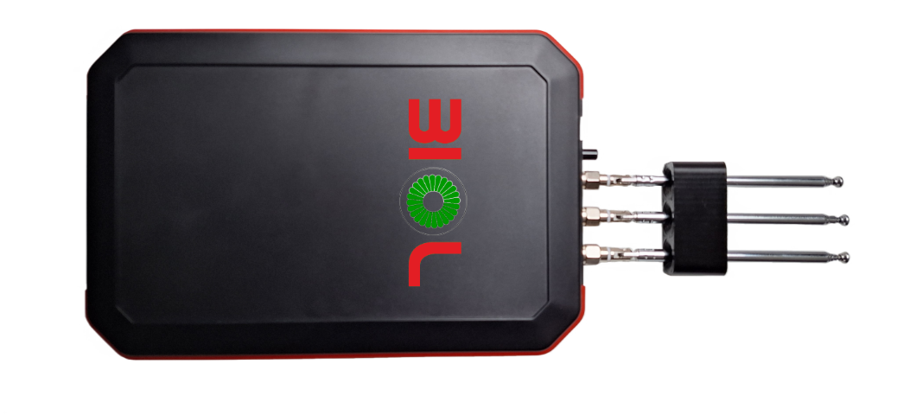

- COMPLETE SET OF MD BIOL

The complete set of MDs BIOL includes the following:
Name of a part |  | Quantity
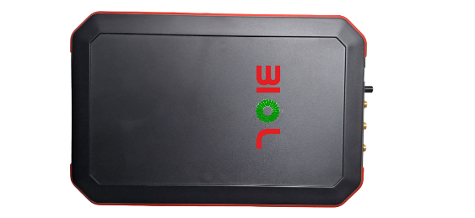 | The unit of MD BIOL | 1
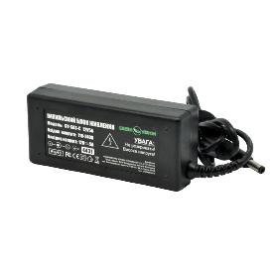 | Power supply unit | 1
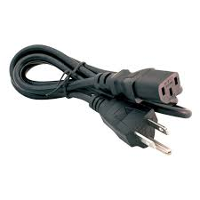 | Power cable | 1
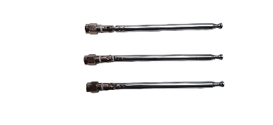 | Antennas | 3
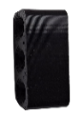 | Antennas holder | 1
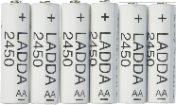 | LADDA AA Battery rechargeable 2450 mA/h | 6
 | Package box or case | 1
IFU (offered in electronic form/available on web) |  | 1

REFERENCES:
- Low-Intensity Electromagnetic Millimeter Waves for Pain Therapy. Taras I. Usichenko, Hardy Edinger, Vasyl V. Gizhko, Christian Lehmann, Michael Wendt, and Frank Feyerherd. Published online 2006 Apr
- Sherwood L, Klandorf H, Yancey P. Animal Physiology: From Genes to Organisms. Vol. 3. Thomson, Brooks/Cole Ch; 2005. pp. 95–100.
- Hotary K, Robinson KR. Endogenous electrical currents and the resultant voltage gradients in the chick embryo. Dev. Biol. 1990; 140:149–160.
- Hotary K, Robinson KR. Evidence of a role for endogenous electrical fields in chick embryo development. Development. 1992; 114:985–996.
- Metcalf M, Shi R, Borgens RB. Endogenous ionic currents and voltages in amphibian embryos. J. Exp. Zool. 1994; 268:307–322.
- Panagopoulos D, Karabarbounis A, Margaritis LH. Mechanism for action of electromagnetic fields on cells. Biochem. Biophys. Res. Commun. 2002; 298:95–102.
- Pall M. Electromagnetic fields act via activation of voltage-gated calcium channels to produce beneficial or adverse effects. Journal of cellular and molecular medicine. 2013; 17:958.
- Levin M. Bioelectromagnetics in morphogenesis. Bioelectromagnetics. 2003; 24:295–315.
- Levin M. Large-scale biophysics: ion flows and regeneration. Trends Cell Biol. 2007; 17:261–270.
- Levin M. Molecular bioelectricity in developmental biology: new tools and recent discoveries: control of cell behavior and pattern formation by transmembrane potential gradients. Bioessays. 2012; 34:205–217.
- Levin M, Stevenson CG. Regulation of cell behavior and tissue patterning by bioelectrical signals: challenges and opportunities for biomedical engineering. Annu. Rev. Biomed. Eng. 2012; 14:295–323.
- McGaig C, Rajnicek AM, Song B, Zhao M. Controlling cell behavior electrically: current view and future potential. Physiol. Rev. 2005; 85:943–978.
- Funk RH, Monsees TK, Ozkucur N. Electromagnetic effects — from cell biology to medicine. Prog. Histochem. Cytochem. 2009:177–246.
- Litovitz T, Krause D, Penafiel M, Elson EC, Mullins JM. The role of coherence time in the effect of microwaves on ornithine decarboxylase activity. Bioelectromagnetics. 1993; 14:395–403.
- Alberts B, Johnson A, Lewis J, Raff M, Roberts K, Walter K. Molecular Biology of the Cell. 4th edition. Garland Science; New York: 2002. pp. 528–530.
- Ermakov A, Pells S, Freile P, Ganeva VV, Wildenhain J, Bradley M, Pawson A, Millar R, De Sousa PA. A role for intracellular calcium downstream of G-protein signaling in undifferentiated human embryonic stem cell culture. Stem Cell Res. 2012; 9:171–184.
- Funk RH, Monsees TK. Effects of electromagnetic fields on cells: physiological and therapeutical approaches and molecular mechanisms of interaction. Cells Tissues Organs. 2006; 182:59–78.
- Persinger M. A potential multiple resonance mechanism by which weak magnetic fields affect molecules and medical problems: the example of melatonin and experimental “multiple sclerosis”. Med. Hypotheses. 2006; 66:811–815.
- Persinger M, Koren SA. A theory of neurophysics and quantum neuroscience: implications for brain function and the limits of consciousness. Int. J. Neurosci. 2007; 117:157–175.
- Sundelacruz S, Levin M, Kaplan DL. Membrane potential controls adipogenic and osteogenic differentiation of mesenchymal stem cells. PLoS One. 2008.
- Sundelacruz S, Levin M, Kaplan DL. Role of membrane potential in the regulation of cell proliferation and differentiation. Stem Cell Rev. 2009; 5:231–246.
- Sundelacruz S, Li C, Choi YJ, Levin M, Kaplan DL. Bioelectric modulation of wound healing in a 3D in vitro model of tissue-engineered bone. Biomaterials. 2013; 34:6695–6705.
- Ikehara T, Yamaguchi H, Miyamoto H. Effects of electromagnetic fields on membrane ion transport of cultured cells. J. Med. Invest. 1998; 45:47–56.
- Лебедева Н.Н., Биологические эффекты низкоинтенсивных миллиметровых волн и их применение в медицине
- О. В. Бецкий, Н. Н. Лебедева Современные представления о механизмах воздействия низкоинтенсивных миллиметровых волн на биологические объекты, Институт радиотехники и электроники РАН; Институт высшей нервной деятельности и нейрофизиологии РАН.
- В.М. Перельмутер, В.А. Ча, Е.М. Чуприкова Медико биологические аспекты взаимодействия эектромагнитных волн с организмом.2009
- Jesse A. Rudd-Schmidt, et al. Lipid order and charge protect killer T cells from accidental death. Nature Communications, 2019, 10:5396; DOI: 10.1038/s41467-019-13385-x

DOCUMENT HISTORY AND VERSION CONTROL

Version | Version Date | Summary of changes | Author | Related documents
1.0 | 2024-11-08 | Created | Team, listed on the title

